CONDITIONAL STATEMENTS
So far the programs that you have written have started from top to bottom and have executed every single line.
In addition to this, the program has run the same way each time, without any decisions being made.
In programming, Conditional Statements allow for certain lines of code to be executed only if certain conditions are true.
We use Boolean

Conditional statements are sometimes referred to as if statements.

Type the following code and see what happens as you input different values:
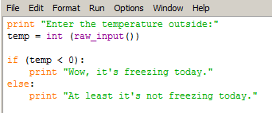

Your program above outputs one message if the temperature is below zero, and outputs a different message if the temperature not below zero.

By using a Boolean Operators called AND we can add more complexity to the program.
We will also have to use some Comparison Operators like == < > <=
Type the following code and then try different temperature inputs:

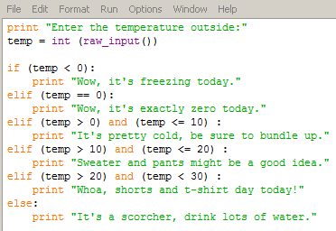

PYTHON COMPARISON OPERATORS

== | equal to
< | less than
<= | less than or equal to
> | greater than
>= | greater than or equal to
!= | not equal to

PYTHON BOOLEAN OPERATORS
and
or
not

Create the following:

- A program that prompts the user for their age. If they are 16 or older it informs them that they can obtain their driver’s license. If they are younger than 16 then it informs them that they cannot obtain their driver’s license.

- A program that prompts the user for the length and width of a rectangle and then calculates the area of a rectangle. If the area of the rectangle is greater than 100 than it outputs the message “That’s a big rectangle!”, otherwise it outputs the message “That’s not a big rectangle.”

- A program that prompts the user to enter a number between 1 and 1000.
If the number is between 1 and 300 it outputs “Small number”
If the number is between 301 and 650 it outputs “Medium number”
If the number if between 651 and 1000 it outputs “Large number”
If the number is less than 1 or larger than 1000 then it outputs “Invalid number”

- Open up an old program and add some type of password verification at the start. This means that you need to prompt the user for a password. If they get the password correct then the program begins, if they get it incorrect than an error message is displayed and the program ends.

- Create a program that asks the user to enter a letter.
If they enter a vowel then it outputs “VOWEL”. If they input a consonant then it outputs “CONSONANT”

- Create a multiple choice program that asks the user a question and then provides four possible answers.
The program outputs a message for each possible response, including a message for the correct answer.

- Add to program four so that the quiz asks the user 5 questions. Each time they answer correctly try to increase their score by using the code score=score + 1 then output their score at the end of the quiz.

- Create a program that generates a random number between 1 and 5 and stores it in a variable. The program should then ask the user to guess a number between 1 and 5 and if they are correct a success message is displayed.
You will need to include the following code at the very top of your program:
import random
You will need to include the following code to generate the random number:
randNumber = random.randint(1,5)

