Activity 4.1: Planning Effective Mathematics Lessons
Steve Floyd

Lesson Title: Linear Relationships
Mathematics Strand: Linear Relations
Expectations:
Overall Expectations
By the end of this course, students will:
- apply data-management techniques to investigate relationships between two variables;
- demonstrate an understanding of the characteristics of a linear relation
- connect various representations of a linear relation.
Specific Expectations
- construct tables of values, graphs, and equations, using a variety of tools (e.g., graphing calculators, spreadsheets, graphing software, paper and pencil), to represent linear relations derived from descriptions of realistic situations
- identify, through investigation, some properties of linear relations (i.e., numerically, the first difference is a constant, which represents a constant rate of change; graphically, a straight line represents the relation), and apply these properties to determine whether a relation is linear or non-linear;
- determine other representations of a linear relation, given one representation (e.g., given a numeric model, determine a graphical model and an algebraic model; given a graph, determine some points on the graph and determine an algebraic model);
Math Processes:
Connecting
Experiences that allow students to make connections – to see, for example, how concepts and skills from one strand of mathematics are related to those from another – will help them to grasp general mathematical principles. As they continue to make such connections, students begin to see that mathematics is more than a series of isolated skills and concepts and that they can use their learning in one area of mathematics to understand another. Seeing the relationships among procedures and concepts also helps deepen students’ mathematical understanding.In addition, making connections between the mathematics they study and its applications in their everyday lives helps students see the usefulness and relevance of mathematics beyond the classroom.
Representing
In secondary school mathematics, representing mathematical ideas and modelling situations generally takes the form of numeric, geometric, graphical, algebraic, pictorial, and concrete representation, as well as representation using dynamic software. Students should be able to go from one representation to another, recognize the connections between representations, and use the different representations appropriately and as needed to solve problems. Learning the various forms of representation helps students to understand mathematical concepts and relationships; communicate their thinking, arguments, and understandings; recognize connections among related mathematical concepts; and use mathematics to model and interpret mathematical, physical, and social phenomena. When students are able to represent concepts in various
ways, they develop flexibility in their thinking about those concepts. They are not inclined to perceive any single representation as “the math”; rather, they understand that it is just one of many representations that help them understand a concept.”
Curriculum Documents Ontario Ministry of Education. (2005).
Big Idea:
“PROPORTIONALITY: If two quantities vary proportionally, that relationship can be represented
as a linear function” (Randall I. Charles, 2015, p. 18)
Learning Goal:
By the end of this lesson, students will be able to:
- construct tables of values to represent linear relations
- identify, through investigation, some properties of linear relations
- determine other representations of linear relations
Instructional Input:

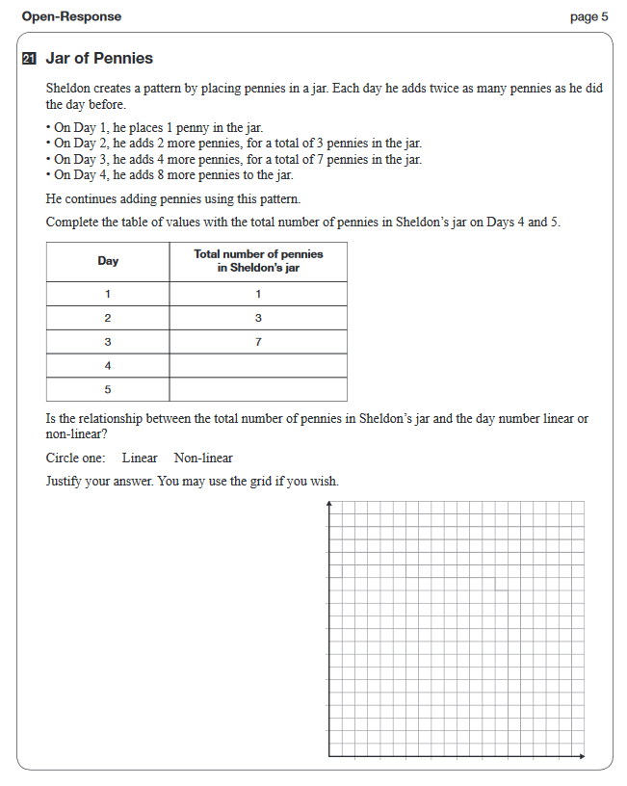

MINDS ON:
- Students will be given the definition of a linear relation and a non-linear relation:
linear relation: A relation between two variables that appears as a straight line when graphed on a coordinate system. May also be referred to as a linear function.
non-linear relation: A relationship between two variables that does not fit a straight line when graphed.
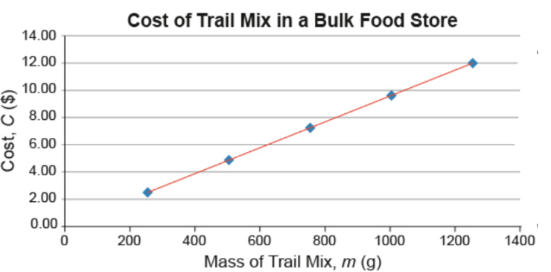
- Students will be shown some examples of linear relations, and non-linear relations and will be asked to classify each one.
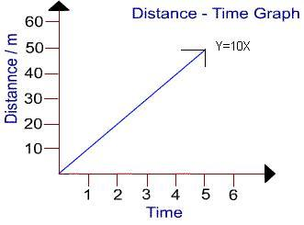

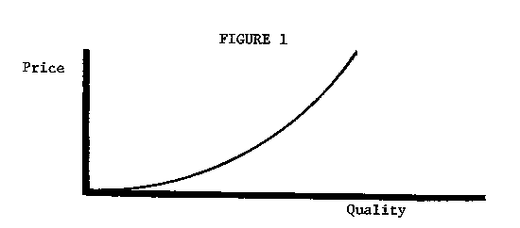
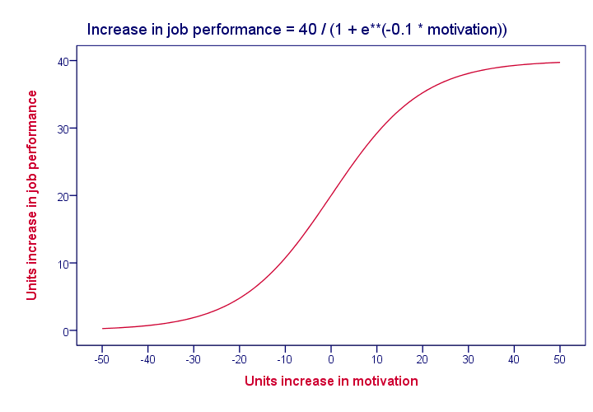

ACTION:

Here students will be given a chance to observe and record real world data.
- Students are put in to groups of four and given an ipad with the tickle app installed, a Sphero ball, a stopwatch and a clipboard with paper.
- Students are to fill out the following table on the clipboard:

Program your Sphero ball to travel 5 meters at the speeds indicated in the table.
Record how long each speed takes:

SPEED | TIME IT TAKES TO TRAVEL 5 METERS
20%
40%
60%
80%
100%

Use the grid to plot the various speeds and times.

Is the relationship between the speed of the Sphero ball and the time it takes to travel 5 meters linear? Explain your answer.

CONSOLIDATION
- Students will be given the EQAO question included above, and will be put in to randomized groups.
- Students will work in groups, at a vertical learning surface (most likely a white board on the wall, or chart paper), to complete the question. Teacher will observe work of all the groups, will advise groups to seek missing information from other groups if necessary.
- Teacher will ensure four things are evident in the group’s answers:
-The student has indicated the correct numbers in the empty spaces of the table
-The student has graphed the correct line
-The student has indicated the correct answer (non-linear)
-The student has justified their answer
- Each group will discuss their answer with the class.

Charles, R. (2005). Big Ideas and Understandings as the Foundation for Elementary and Middle School Mathematics.
Journal of Mathematics Education Leadership, volume 7, number 3, 1-24.
Curriculum Documents Ontario Ministry of Education. (2005). The Ontario curriculum grades 9-10: Mathematics.
Retrieved from http://www.edu.gov.on.ca/eng/curriculum/secondary/math910curr.pdf

