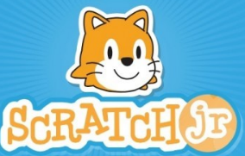
CREATING YOUR OWN STORIES

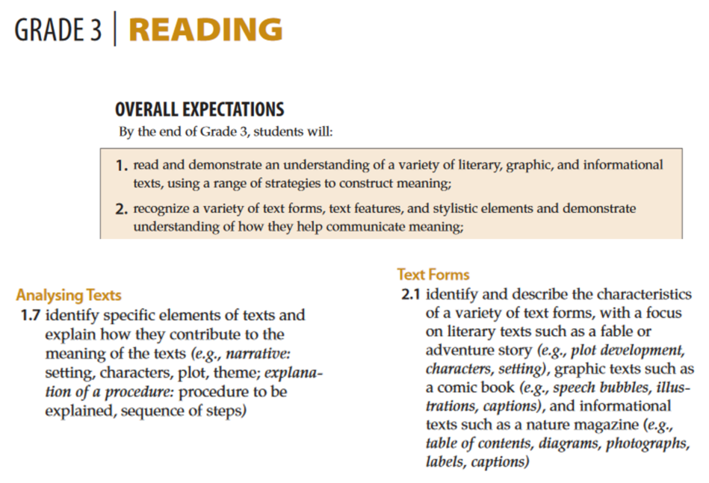

Today you are going to get a chance to write your own story using Scratch Jr.
But instead of writing your story right away, you are going to plan out your story first.
Before you begin, you will decide on these three things:
The Setting, the Character and the Plot.

The Setting: The setting is where the story takes place.
In Scratch Jr, you have a few different settings to chose from.
Does your story take place on a farm?
On a basketball court?
At night on a lake?
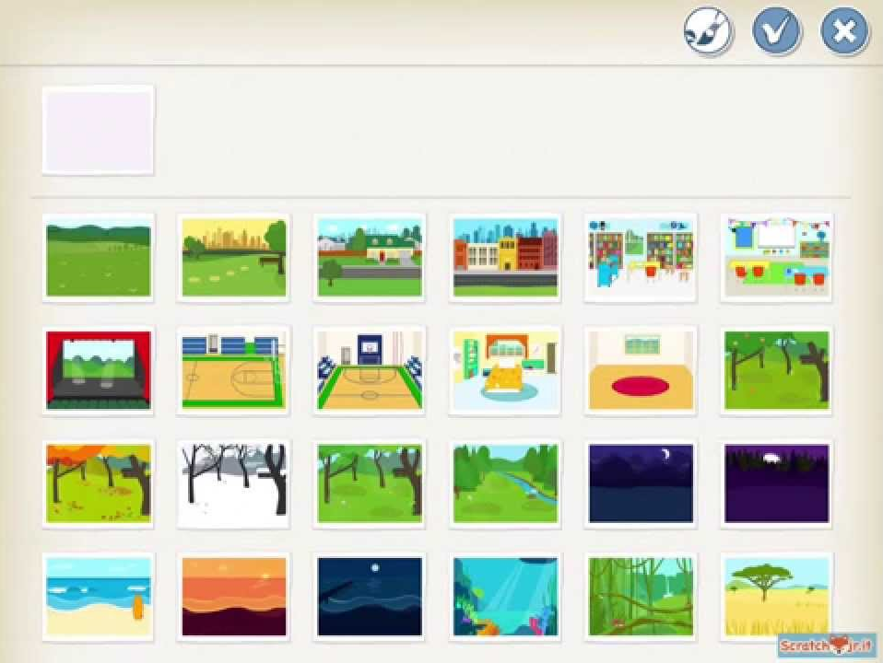

Character: The character is the person or the animal that is in the story.
It is possible to have more than one character in your story.
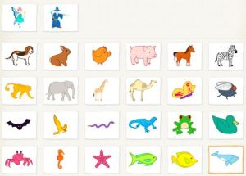

Plot: The plot includes the main events that happen in your story.

Read this story and think about the setting, the character and the plot.
Frederick was a little green frog who loved to spend his day hopping.
One day Frederick walked to his bed and climbed on top.
He hopped three times on his bed, but on his fourth hop he tumbled off and bumped his head.
After that day, Frederick has decided to only hop when it’s safe.
What a smart frog.

Who is the character in this story?
What is the plot of the story?
What is the setting of the story?

Read this story and think about the setting, the character and the plot.
Fionna the fish was swimming back and forth, just below the surface of the ocean.
This was her favourite place to swim, she loved the temperature of the water.
Suddenly she spotted her favourite pink corral.
She loved the feel of the pink corral on her gills, so she swam down deeper in the ocean.
She swam around the corral five times.
When she was done, she did a funny little happy dance to show the other fish how excited she was.

Who is the character in this story?
What is the plot of the story?
What is the setting of the story?

It is now time to write your own story.
Make sure you carefully think about the setting, the character and the plot.

When you are done writing your own story, find a partner who is also finished.
See if you can figure out the setting, the character and the plot for each other’s stories.

