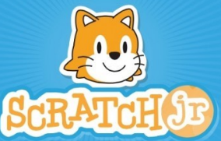
Movement
Transformations:
Translations, Rotations, Refelction and Resizing
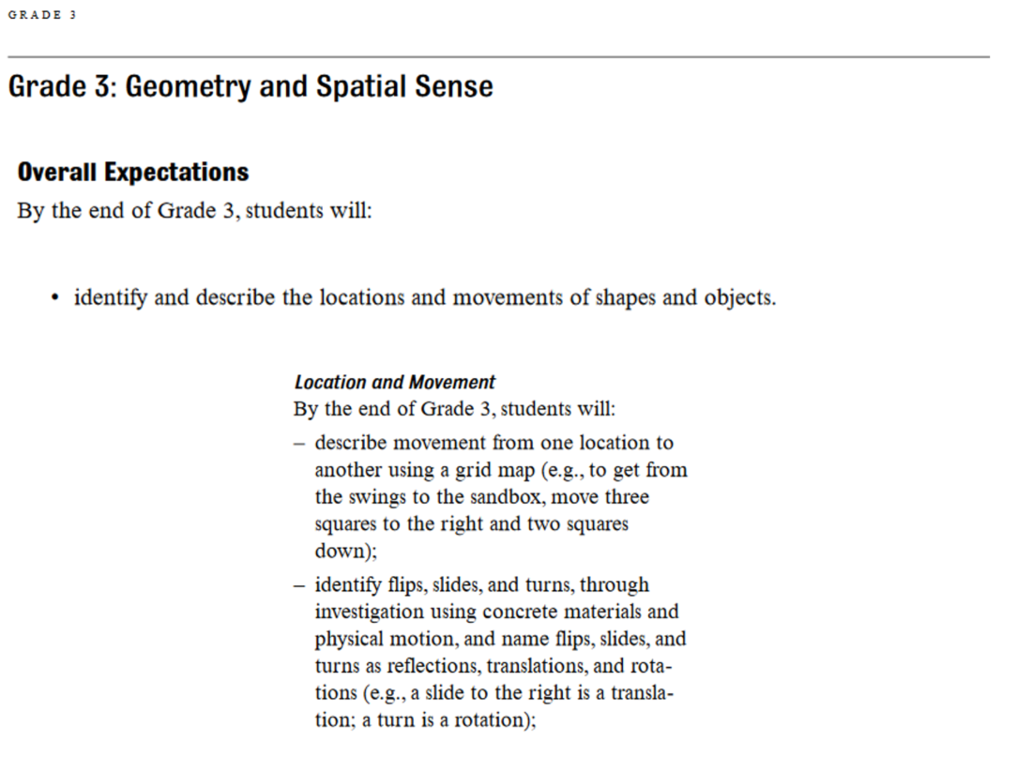

A transformation is when an object, like Scratch the Cat, is moved.
A Translation (Scratch Slides):
When Scratch the Cat moves places, from one point to another.
A Rotation (Scratch Spins):
When Scratch the Cat spins.
Reflection (Scratch Flips and points in other direction):
When Scratch the Cat flips, and faces the other direction.
Resizing (Scratch Shrinks or Grows):
When Scratch the Cat gets bigger, or smaller.

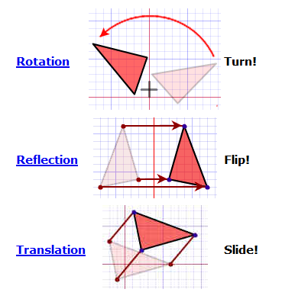

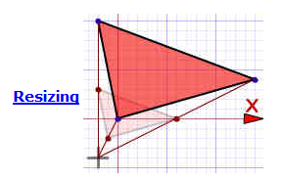

Can you make Scratch do a dance where he goes through all four transformations?
Scratch should do:
- a translation (a slide)
- a rotation (a spin)
- a reflection (should flip and point in the other direction).
- a resizing (should grow or shrink)

Add a Wait block after each transformation.
See if you can loop this program forever.
See if you can add the sound of your voice, naming each transformation as it occurs.

A Translation (Scratch Slides):
When Scratch the Cat moves places, from one point to another.
A Rotation (Scratch Spins):
When Scratch the Cat spins.
Reflection (Scratch Flips and points in other direction):
When Scratch the Cat flips, and faces the other direction.

Resizing (Scratch Shrinks):
When Scratch the Cat gets bigger, or smaller.

