Movement
Grids

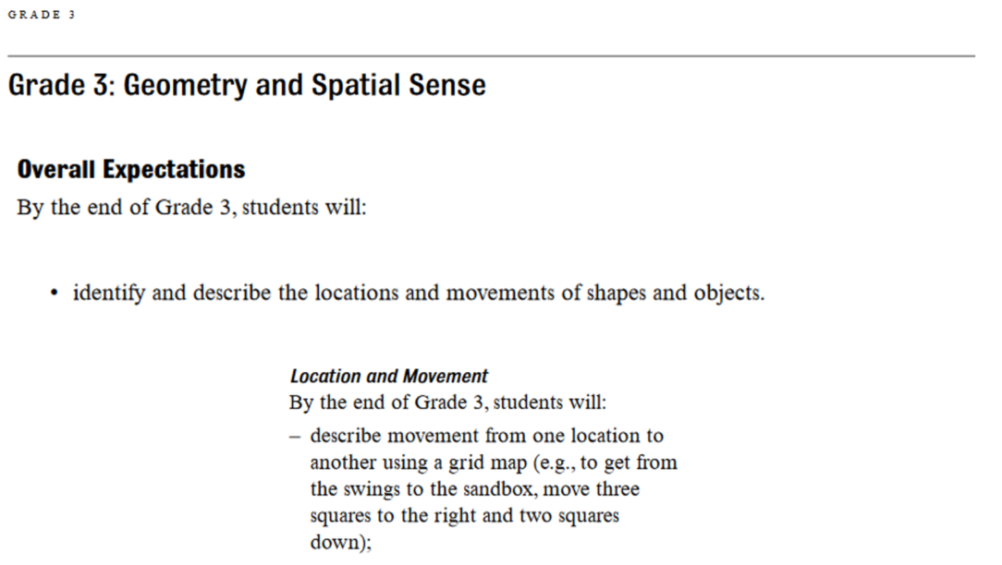

In Scratch Jr it is possible to have a grid appear on the screen.
A grid is a whole bunch of lines that cross each other creating squares or rectangles.
A grid lets us describe how something is moving and lets us talk about where something is located.
You can turn the grid on in Scratch Jr by clicking the Grid button:

With the grid turned on, it is now really easy to explain locations on the screen.
Can you see why we would say that ScratchJr is located at spot 11, 8?
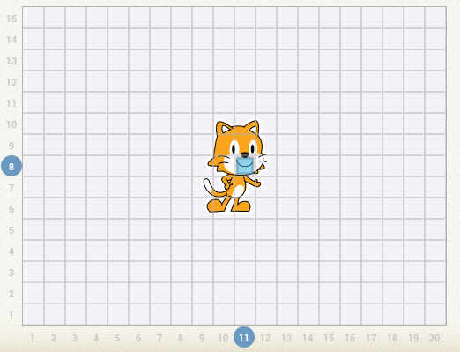

This grid gives us something called the x-axis and the y-axis.
The x-axis includes the numbers along the bottom.
The y-axis includes the numbers that go upwards, on the left.
We would say that Scratch Jr is at spot 11 on the x-axis and at spot 8 on the y-axis.

With the grid turned on, it also makes it easier to describe movement that is taking place.
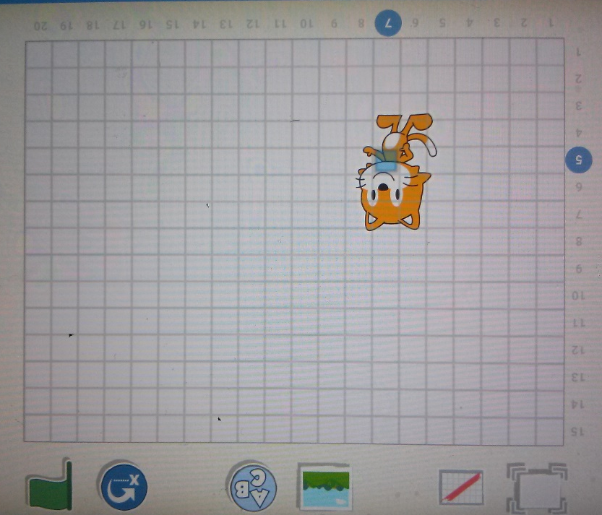
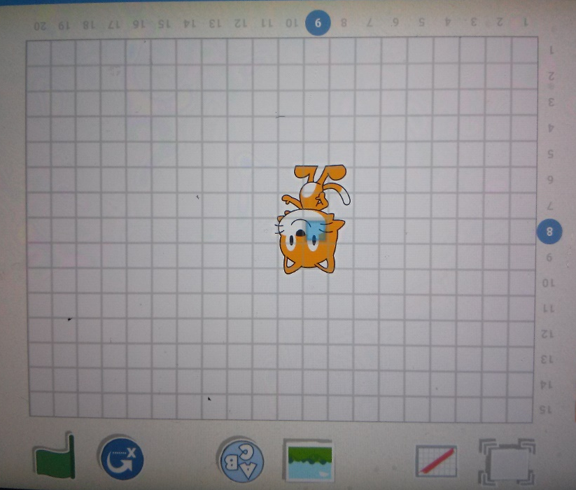
Take a look at these two images:
Can you tell us Scratch Jr’s exact location in each one?
Can you tell us how many places Scratch Jr moved, from one image to the next, along the x-axis?
Can you tell us how many places Scratch Jr moved, from one image to the next, along the y-axis?

Can you create the following programs, then have a partner check them to make sure they are correct?
- Have Scratch Jr start at point 5, 9.
Make him move to point 13, 4.
- Have Scratch Jr start at point 4, 2.
Make him move to point 13, 6.
Then make him move back to point 4,2.
- Have Scratch Jr start at point 6, 4.
Make him move 5 positions along the x-axis.
Then Make him move 3 positions along the y-axis.
What location is he now at?

Try to figure this out without using Scratch Jr:
Scratch Jr starts at point 4, 4.
He then moves 3 positions to the right, along the x-axis.
He then moves 2 positions down, along the y-axis.
What is Scratch Jr’s new location?

Try to figure this out without using Scratch Jr:
Scratch Jr starts at point 9, 13.
He then moves to position 7, 9.
How many positions did Scratch Jr move along the x-axis and in what direction?
How many positions did Scratch Jr move along the y-axis and in what direction?

