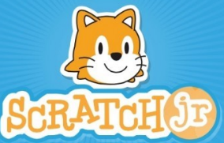

**Frederick was a little green frog who loved to spend his day hopping.**

**One day Frederick walked to his bed and climbed on top.**

**He hopped three times on his bed, but on his fourth hop he tumbled off and bumped his head.**

**After that day, Frederick has decided to only hop when it’s safe.**

**What a smart frog.**

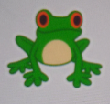

**Program this story in ScratchJr using an appropriate background and sprite.**

**You may want to decompose this story into separate parts first.  
This might make it easier to program.**

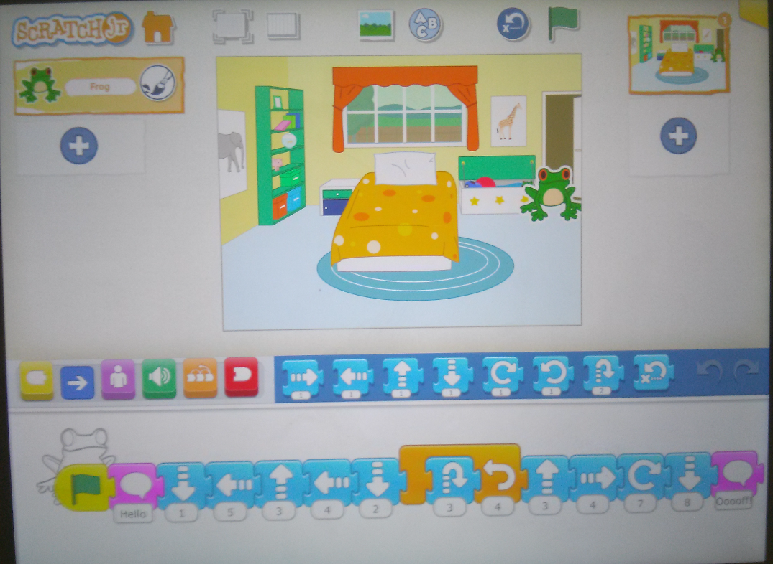



**Fionna the fish was swimming back and forth, just below the surface of the ocean.**

**This was her favourite place to swim, she loved the temperature of the water.**

**Suddenly she spotted her favourite pink corral.**

**She loved the feel of the pink corral on her gills, so she swam down deeper in the ocean.**

**She swam around the corral five times.**

**When she was done, she did a funny little happy dance to show the other fish how excited she was.**

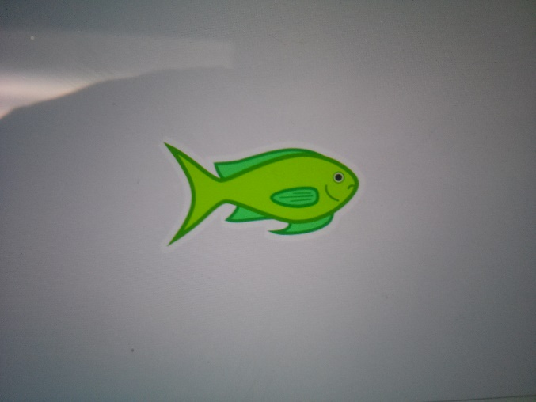

**Program this story in ScratchJr using an appropriate background and sprite.**

**You may want to decompose this story into separate parts first.  
This might make it easier to program.**

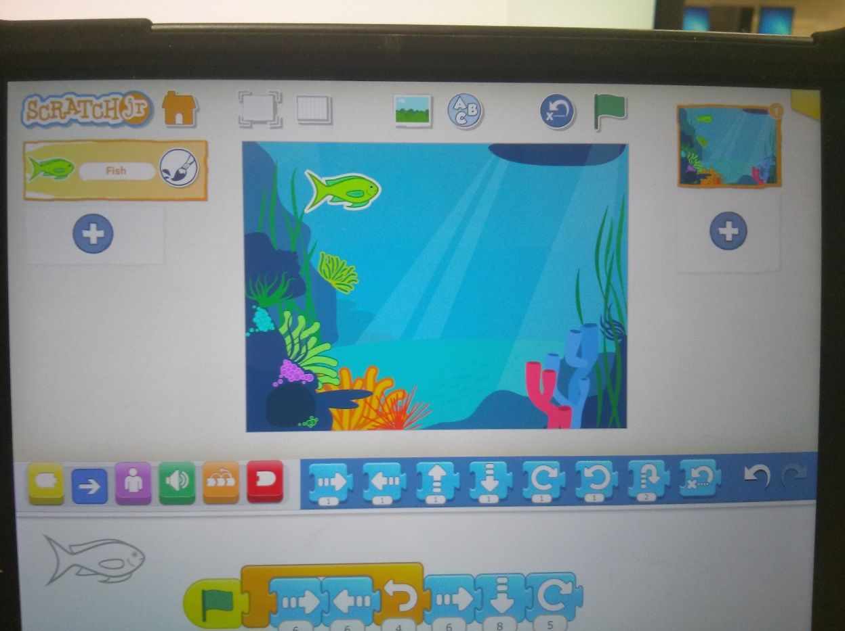

**Create your own story using ScratchJr.**

**Be sure to carefully select your background and sprite.**

**Think carefully about each of the different parts of your story?**

**When you are done, write your story down on paper but keep it hidden.**

**Play your ScratchJr program for a partner, but don’t tell them your story.**

**Have your partner write down a story based on your program.**

**Share your stories. Are they the same?**

